Name: Ekta Narayan Sawant
Roll no: 2401103
Batch: T22

ASD&D Experiment No. 07

Aim: To implement monitoring using Prometheus / Grafana / Nagios
LO Mapping: LO5
LO5: Implement ML lifecycle management and automated workflows using MLflow, Airflow, and monitoring tools like Prometheus/Grafana/Nagios.

Theory:
Continuous monitoring is a process to detect, report, respond all the attacks which occur in its infrastructure. Once the application is deployed into the server, the role of continuous monitoring comes in to play. The entire process is all about taking care of the company's infrastructure and respond appropriately.

Why We Need Nagios tool?
Here, are the important reasons to use Nagios monitoring tool:
- Detects all types of network or server issues
- Helps you to find the root cause of the problem which allows you to get the permanent solution to the problem
- Active monitoring of your entire infrastructure and business processes
- Allows you to monitor and troubleshoot server performance issues
- Helps you to plan for infrastructure upgrades before outdated systems create failures
- You can maintain the security and availability of the service
- Automatically fix problems in a panic situation
- Nagios is the most popular, open source, powerful monitoring system for any kind of infrastructure. It enables organizations to identify and resolve IT infrastructure problems before they affect critical business processes. Nagios has the capability of monitoring applications, services and entire IT infrastructure.
- NRPE is known as Nagios Remote Plugin Executor. It is designed to execute plugins on remote systems. On Windows hosts, the equivalent remote agent is NSClient++, which listens for Nagios requests and executes local checks (disk, CPU, memory, services, etc.).
- NSClient++ runs as a Windows service on the remote host and waits for requests from the Nagios server (usually over the NRPE protocol, which NSClient++ also supports). When the Nagios server needs to check a resource on that host, it sends a command; NSClient++ executes the check locally and returns the result to Nagios.

Note on running Nagios on Windows
Nagios Core is built for Linux and does not install natively on Windows. The standard practice for a Windows machine is to run the Nagios Core server inside a Docker container (using Docker Desktop with the WSL2 backend), and to monitor Windows hosts using NSClient++, which is the Windows counterpart of NRPE. All commands below are Windows PowerShell / Command Prompt commands.

Output:
Step 1: Verify Docker and WSL2
The Docker and WSL2 installations were verified using:
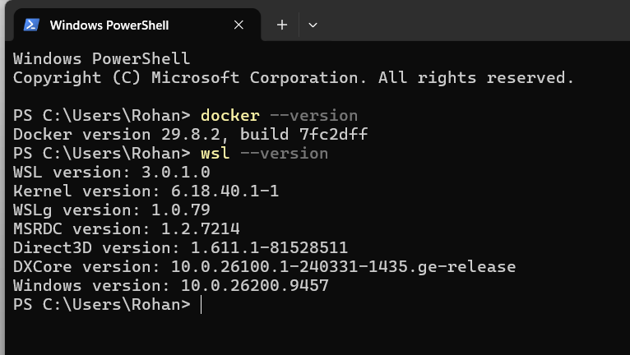
Step 2: Pull Nagios Docker Image
The Nagios Docker image was downloaded using:
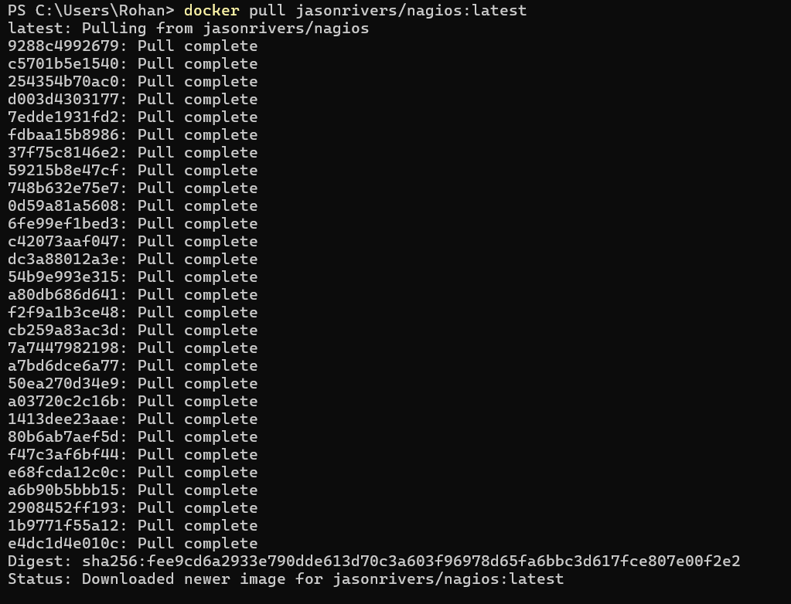
The image was successfully downloaded.
Then the Nagios container was created using:
The container was verified using:
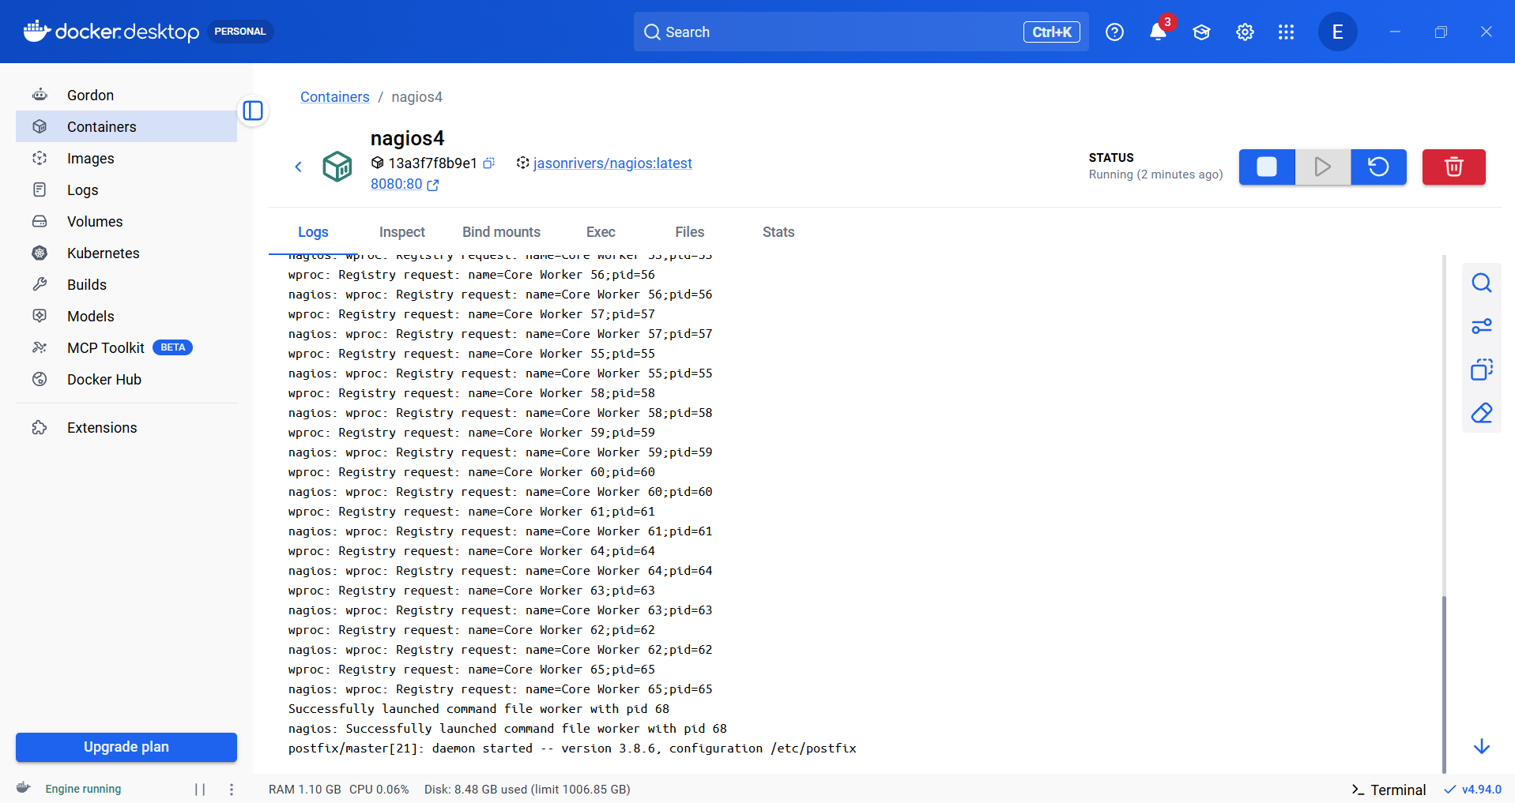
Step 3: Configure Nagios Admin Password
The Nagios administrator password was configured using:
Step 4: Access Nagios Web Interface
Nagios was accessed through:
http://localhost:8080/nagios/
The administrator credentials were used to log in.
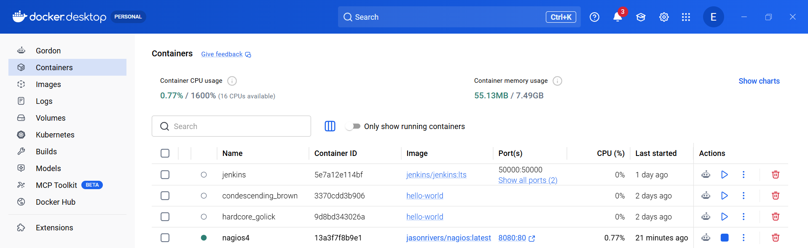
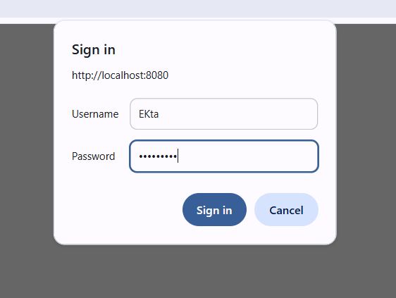

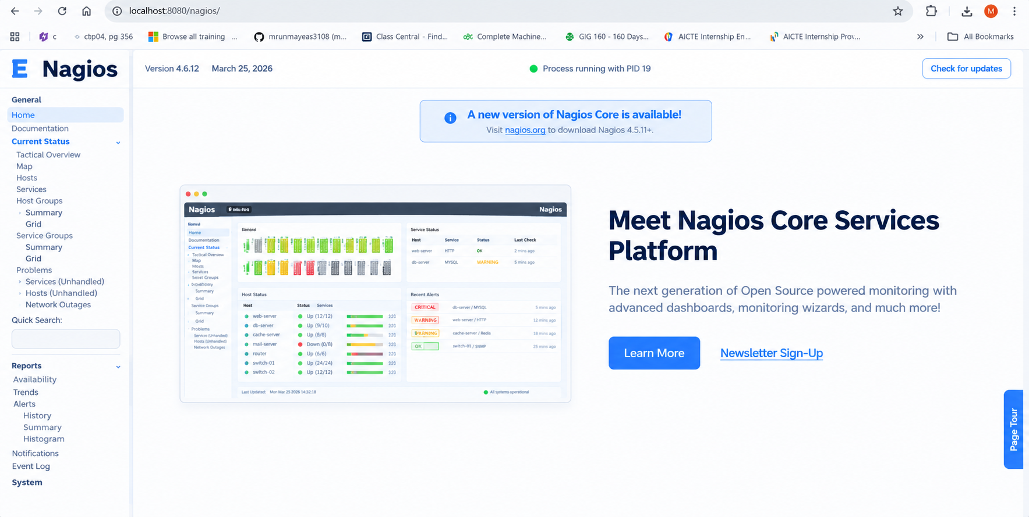
Step 5: Install and Configure NSClient++
NSClient++ was installed on the Windows system to act as the Windows monitoring agent.
The NSClient++ service was verified using:
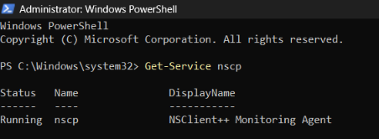
Step 6: Verify NSClient++ Monitoring Port
NSClient++ uses port 5666 for NRPE communication.
The port was verified using:
Step 7: Configure Windows Host in Nagios
A Nagios configuration file was created:
/opt/nagios/etc/servers/MyWindowsHost001.cfg
The Windows host was configured with:
Host Name: Windows_Host_001
Alias: Windows Host 001
Because direct PING/NRPE connectivity to the Windows LAN address was unavailable from the Docker network, the monitoring endpoint was configured using:
host.docker.internal
and NSClient++ port:
5666
This allowed Nagios to monitor the Windows host through the reachable NSClient++ endpoint.
Step 8: Validate Nagios Configuration
The Nagios configuration was checked using:
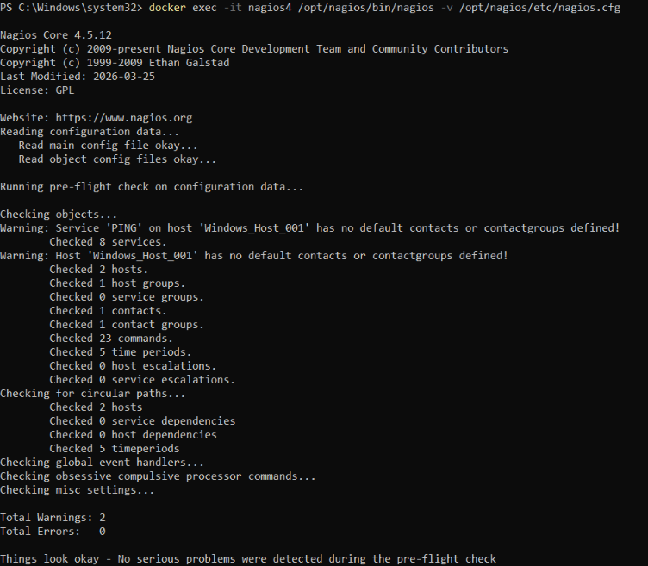
Step 9: Restart Nagios
After configuration, the Nagios container was restarted using:
Step 10: Verify Host in Nagios
The Nagios web interface was opened again:
http://localhost:8080/nagios/
Then:
Current Status → Hosts

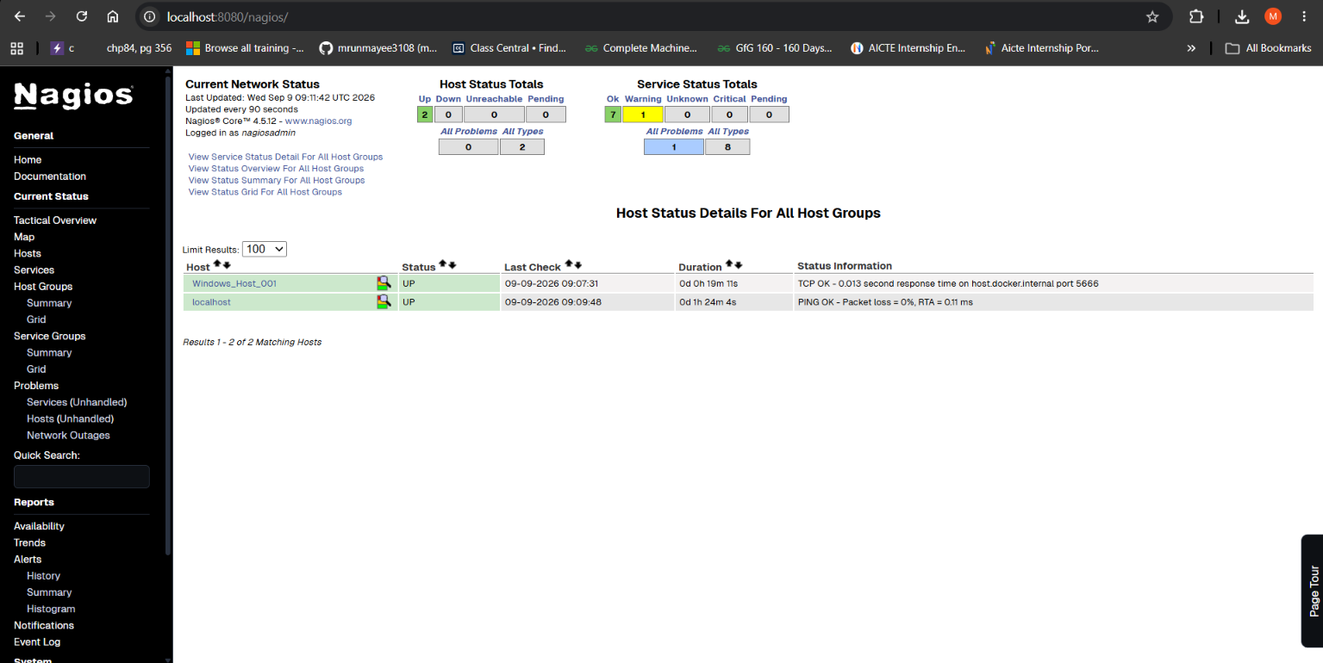

Results
Nagios Core was successfully deployed inside a Docker container on Windows. NSClient++ was configured as the Windows monitoring agent, and the Windows host was successfully added to Nagios.
The final Nagios dashboard showed:
Windows_Host_001 → UP
with a successful TCP monitoring response from the NSClient++ monitoring port.

Conclusion:
Thus, monitoring was successfully implemented using Nagios Core running in Docker. NSClient++ was configured on the Windows system as the monitoring agent, and the Windows host was successfully added and monitored through the Nagios web interface. The final monitoring status of the configured host was verified as UP.

